A Project Report on

CANTEEN ORDERING SYSTEM
submitted in partial fulfillment of the requirements for the award of the degree of
BACHELOR OF ENGINEERING
By
Vedang Karmalkar: 24106004
Vinay Handge: 24106114
Suraj Gupta: 24106049
Prince Gupta: 24106087

Under the Guidance of
Prof. Vijaya Bharathi Jagan


Department of Computer Science & Engineering
(Artificial Intelligence & Machine Learning)
A. P. SHAH INSTITUTE OF TECHNOLOGY, THANE
2025-2026

A. P. SHAH INSTITUTE OF TECHNOLOGY, THANE

CERTIFICATE

This is to certify that the project entitled "Canteen Ordering System" is a bonafide work of Vedang Karmalkar (24106004), Vinay Handge (24106114), Suraj Gupta (24106049), Prince Gupta (24106087) submitted to the University of Mumbai in partial fulfilment of the requirement for the award of the degree of Bachelor of Engineering in Computer Science & Engineering (Artificial Intelligence & Machine Learning).

Prof. Vijaya Bharathi J Prof. Vijaya Bharathi J
Guide Project Co-ordinator
Dr. Jaya Gupta Dr. Uttam Kolekar
Head of Department Principal


A. P. SHAH INSTITUTE OF TECHNOLOGY, THANE

Project Report Approval for S.E.

This project report entitled "Canteen Ordering System" by Vedang Karmalkar, Vinay Handge, Suraj Gupta, Prince Gupta is approved for the degree of Bachelor of Engineering in Computer Science & Engineering (Artificial Intelligence & Machine Learning), 2025-26.

Examiner Name Signature
1. ____________________________ _____________________
2. ____________________________ _____________________

Date:
Place:

Declaration

We declare that this written submission represents our ideas in our own words and where others' ideas or words have been included, we have adequately cited and referenced the original sources. We also declare that we have adhered to all principles of academic honesty and integrity and have not misrepresented or fabricated or falsified any idea/data/fact/source in our submission. I understand that any violation of the above will be cause for disciplinary action by the Institute and can also evoke penal action from the sources which have thus not been properly cited or from whom proper permission has not been taken when needed.

---------------------------------
(Signature)
---------------------------------
(Vedang Karmalkar : 24106004)

---------------------------------
(Signature)
----------------------------------
(Vinay Handge : 24106114 )

---------------------------------
(Signature)
----------------------------------
(Suraj Gupta : 24106049 )

---------------------------------
(Signature)

---------------------------------
(Prince Gupta : 24106087 )
Date:
Abstract

The Canteen Ordering System is a web-based application developed to modernize and streamline food ordering operations at A. P. Shah Institute of Technology (APSIT), Thane. The existing manual canteen process suffers from severe overcrowding during peak recess hours, leading to significant wastage of students' limited break time, frequent billing errors, and general operational inefficiency. This project proposes a comprehensive digital solution that enables students to browse the canteen menu, place pre-scheduled food orders online, make digital payments through UPI or a built-in digital wallet, and track their order status in real time — all without standing in a physical queue.
The system is built using HTML5, CSS3, and JavaScript on the front-end, PHP 8.1 on the back-end, MySQL 8.0 as the database, and Apache Web Server via XAMPP as the deployment environment. Two distinct user roles are supported: a Student Dashboard for browsing, ordering, and tracking; and an Admin Dashboard for managing menus and monitoring orders.
A review of five prior studies reveals that existing digital canteen solutions are constrained by high hardware costs, absence of real-time order tracking, limited payment options, and lack of pre-scheduling. The proposed system addresses all these gaps. This project aligns with Sustainable Development Goal 9 (Industry, Innovation and Infrastructure) and Sustainable Development Goal 12 (Responsible Consumption and Production) by promoting innovation through efficient software design while ensuring responsible resource utilization and sustainable development practices.

Keywords: Canteen Management, Web Application, Pre-Scheduling, Real-Time Tracking, PHP, MySQL, Digital Payment, XAMPP, SDG.

TABLE OF CONTENTS
Contents
1. Introduction 1
1.1 Background and Motivation 2
1.2 Scope of the Project 2
1.3 Problem Definition 2
1.4 SDG Alignment 3
2. Literature Survey 4
2.1 Android-Based Food Ordering with Raspberry Pi 4
2.2 Web-Based Canteen System with OTP Login and Online Payment 5
2.3 QR Code-Based Ordering with Online Payment 5
3. Limitation of Existing Systems 7
3.1 High Hardware Dependency and Installation Cost 7
3.2 Absence of Real-Time Order Status Tracking and Multi-Canteen Integration 8
3.3 Limited Payment Flexibility and Inability to Pre-Schedule Orders 8
4. Problem Statement and Objectives 10
4.1 Problem Statement 10
4.2 Objectives 11
5. Proposed System 12
5.1 System Overview 12
5.2 Proposed Methodology 13
5.3 System Architecture 13
5.4 Data Flow Diagram 14
5.5 Use Case Description 14
5.6 System Modules Implemented 15
5.6.1 Authentication Module 15
5.6.2 Menu Management Module 15
5.6.3 Order and Cart Module 16
5.6.4 Pre-Scheduling Module 16
5.6.5 Real-Time Order Tracking Module 16
6. Experimental Setup 18
6.1 Software Requirements 18
6.2 Hardware Requirements 19
6.3 Performance Evaluation Parameters 19
7. Results and Discussion 21
7.1 System Functionality Testing Results 21
7.2 Performance Metrics 22
7.3 Discussion and Analysis 22
7.3.1 Impact of Pre-Scheduling on Queue Elimination 22
7.3.2 Billing Accuracy and Financial Trust 23
7.3.3 Real-Time Tracking and User Satisfaction 23
7.3.4 Usability and Learnability 24
8. Conclusion and Future Work 25
8.1 Conclusion 25
8.2 Summary of Objectives Achieved 26
8.3 Scope of Improvement — Future Work 26
References 28

LIST OF FIGURES
Figure 5.1: Data Flow Diagram Level 0 (Context Diagram) 14
Figure 5.2: Menu Management 15
Figure 5.3: Pre-Scheduling Module 16
Figure 5.4: Real-Time Order Tracking Module 17
Figure 7.1: Bill Accuracy and Financial Trust 23
Figure 7.2: Real-Time Tracking and User Satisfaction 24

LIST OF TABLES
Table 2.1: Summary of Literature Survey 6
Table 3.1: Research Gaps in Existing Systems 9
Table 6.1: Hardware and Software Requirements 19
Table 7.1: Performance Metrics: Manual vs. Digital System 22

LIST OF ABBREVIATIONS
AJAX Asynchronous JavaScript and XML
API Application Programming Interface
CSS Cascading Style Sheets
DFD Data Flow Diagram
ER Entity Relationship
HTML HyperText Markup Language
HTTP HyperText Transfer Protocol
JS JavaScript
MySQL My Structured Query Language
OTP One Time Password
PHP Hypertext Pre-Processor
QR Quick Response
RFID Radio Frequency Identification
SDG Sustainable Development Goal
SDLC Software Development Life Cycle
UI User Interface
UPI Unified Payment Interface
UX User Experience
XAMPP Cross-Platform Apache MariaDB PHP Perl

Chapter 1
Introduction

1. Introduction
The modern educational institution is a bustling ecosystem where time is a precious resource for every stakeholder — from students and faculty to administrative and support staff. Among the many support services that shape daily student life, the campus canteen occupies a uniquely significant position. It is the central social and nutritional hub of the institution, serving hundreds of students simultaneously during short, fixed break periods. However, in many institutions — including A. P. Shah Institute of Technology, Thane — canteen operations have remained entirely manual, creating a cascade of inefficiencies that directly degrade the quality of student life and operational performance.
The Canteen Ordering System is a web-based application developed to address these inefficiencies comprehensively. It enables students to place food orders digitally, schedule pickups for specific break times, make cashless payments via UPI or digital wallet, and track order status in real time — all from any standard web browser, with no specialized hardware installation required. The project falls under the Software category and aligns with two United Nations Sustainable Development Goals: SDG 9 (Industry, Innovation and Infrastructure) and SDG 12 (Responsible Consumption and Production).

1.1 Background and Motivation
Currently, the campus canteen at APSIT operates entirely on a walk-in, cash-first, manual ordering model. Students must physically visit the canteen counter during their recess or lunch break, verbally place their orders, wait near the counter for preparation, collect their food, and pay cash. This process, while simple in concept, breaks down when hundreds of students attempt to do the same thing simultaneously within a 15–20 minute window.
The consequences are multifaceted. Students spend the majority of their break in a queue rather than eating and resting, which negatively impacts their health and academic performance. Counter overcrowding creates safety hazards and disrupts canteen staff workflow. Manual billing under peak-hour pressure leads to calculation errors. The absence of any pre-ordering mechanism means all demand arrives simultaneously, overwhelming both staff and physical space. These compounding issues motivated the development of a comprehensive digital ordering solution.

1.2 Scope of the Project
The scope of this project encompasses the design, development, and testing of a full-stack web application serving two primary user roles: Student and Admin. For students, the system provides menu browsing, item selection, cart management, pre-scheduling of orders by break time, digital payment via UPI or institutional wallet, and real-time order status tracking. For administrators, the system offers a dashboard for viewing and managing incoming orders, updating menu items and prices, and accessing order history.
The system is designed to run on any standard web browser without any client-side software installation. It is hosted on a local server using XAMPP, making it suitable for intranet deployment within the campus. The current version supports a single canteen with architectural provisions for multi-canteen expansion in future phases.

1.3 Problem Definition
The core problem addressed by this project is the operational inefficiency of the manual canteen system at APSIT, which manifests in the following measurable ways:
- Students spend an average of 10–15 minutes of their break time in the queue, leaving only 5–10 minutes for actual eating.
- Counter overcrowding creates physical hazards and disrupts canteen staff during peak hours.
- Manual billing under pressure leads to frequent calculation errors and financial discrepancies.
- The absence of a real-time order status display forces students to wait anxiously at the counter.
- Cash-only transactions slow down the payment process and introduce the risk of cash mismanagement.
- The lack of pre-ordering leads to poor inventory planning, resulting in food wastage or stock shortages.

The Canteen Ordering System is proposed as a holistic digital solution that eliminates each of these pain points through technology-driven process redesign.

1.4 SDG Alignment
This project is designed with a commitment to sustainable development. It aligns with SDG 9 — Industry, Innovation and Infrastructure — by leveraging digital technology to build resilient and innovative campus infrastructure that improves institutional service quality. It also aligns with SDG 12 — Responsible Consumption and Production — by digitizing the ordering process to reduce food wastage through better demand visibility and pre-scheduling, thereby promoting responsible production planning.

Chapter 2
Literature Survey

2. Literature Survey
A systematic review of existing literature was conducted to understand the current state of canteen and food ordering systems in academic institutions, identify the techniques and technologies employed, evaluate their effectiveness, and pinpoint the research gaps that the proposed system aims to fill. A minimum of five peer-reviewed and published studies are surveyed below.

2.1 Android-Based Food Ordering with Raspberry Pi
In [1], they proposed an Android-based food ordering system using a Raspberry Pi single-board computer as the central processing unit, connected to physical display screens at the canteen counter. Orders placed via the Android application were transmitted to the Raspberry Pi over Wi-Fi, which displayed them on the counter screen for staff to process. The dataset comprised real-time order data generated directly from student orders through the app. The system successfully demonstrated reduced queue waiting time and faster order processing compared to the fully manual baseline. The Raspberry Pi also maintained a lightweight MySQL database for order logging.
However, the primary limitation of this approach is its heavy dependence on proprietary hardware. The Raspberry Pi unit, display screens, associated cables, and wiring represent a significant upfront infrastructure investment that may not be feasible for every institution. Hardware components are also vulnerable to failure — a malfunctioning Raspberry Pi would render the entire ordering system inoperable. Furthermore, the Android application requires installation on each user's device, creating an adoption barrier.

2.2 Web-Based Canteen System with OTP Login and Online Payment
2.2.1 In [2], they have developed a web-based canteen management system featuring OTP-based secure login and online payment gateway integration. The system was built without a publicly available dataset, relying on real-time user and order data generated through the system. It enabled digital payment tracking and incorporated a user feedback mechanism, representing a meaningful step forward in user engagement and payment modernization compared to cash-only systems.
However, a critical gap in this system is the complete absence of any real-time order tracking mechanism. After placing an order, students have no way of knowing whether their food is being prepared, is ready, or has been delayed — forcing them to either wait anxiously near the counter or make repeated verbal inquiries to staff, defeating the purpose of the digital system. Additionally, the system did not incorporate a token or order ID generation mechanism, making counter management and order attribution difficult for canteen staff.
2.2.2 In [4], they have proposed a smart canteen management system for Android that featured a built-in institutional e-wallet secured using AES 128-bit encryption. The dataset comprised real-time user transaction data including student and staff records. The system replaced cash transactions with a closed digital wallet that students pre-loaded with money, significantly reducing cash-handling delays. Queue time was reduced substantially by eliminating change-giving and cash verification.
While the security architecture was robust, the system's closed wallet model is a notable limitation. Students were required to transfer money specifically into the institutional wallet, which introduces friction compared to open UPI-based payments. The system also did not support pre-scheduling of orders, meaning it still failed to address the root cause of simultaneous demand peaks at the counter.

2.3 QR Code-Based Ordering with Online Payment
2.3.1 In [3], they have presented a web-based canteen system utilizing QR code scanning for user login and menu access, combined with online payment integration. The dataset used was real-time canteen order data generated by the system during operation. The system achieved reduced queues and faster billing compared to manual systems and established a digital record of all transactions.
The limitations identified were a lack of discussion around system scalability, and the absence of multi-canteen support — meaning the system could only manage a single food outlet. Furthermore, the QR-code login mechanism, while innovative, adds a procedural step that may slow down access for students who must scan a code every time they wish to order. No pre-scheduling functionality was implemented.

2.3.2 In [5], they have developed a QR code-based food ordering system that simplified menu access and eliminated the need for printed menu boards. The system used real-time transactional data and was described as simple to implement and effective at reducing reliance on physical printed materials.
However, a critical gap in this system is the complete absence of pre-scheduling functionality. Users could only order food immediately at the time of interaction; the system had no provision for a student to place an order in advance for a future break time. This means the system fails to solve the fundamental problem of students rushing to the canteen counter simultaneously during a short break window, as all orders still arrive at the same peak moment.
Table 2.1: Summary of Literature Survey
Author & Year | Technology Used | Key Contribution | Key Limitation
Kale et al., 2020 [1] | Android App, Raspberry Pi, XAMPP, MySQL | Reduced queue time via digital display at counter | Expensive proprietary hardware; hardware failure = system down
Antony et al., 2022 [2] | Web-based, OTP Login, Online Payment Gateway | Secure digital payment, user feedback system | No real-time order tracking; no token/order ID generation
Bari et al., 2024 [3] | Web-based, QR Code Login, Online Payment | Faster billing, digital records, reduced queues | No multi-canteen support; no pre-scheduling feature
Katkar & Jangale, 2018 [4] | Android, AES-128 Encrypted E-Wallet | Secure cashless transaction; eliminated cash queues | Closed institutional wallet only; no pre-scheduling
Bhattarai et al., 2024 [5] | QR Code-Based Web System | Paperless menus; simple, low-cost implementation | No pre-scheduling; immediate ordering only; no tracking

Chapter 3
Limitation of Existing Systems

3. Limitation of Existing Systems
The literature survey reveals a consistent and recurring pattern of limitations across existing digital canteen and food ordering systems that prevent them from being fully effective solutions for the operational context of an institution like APSIT. These limitations are identified, categorized, and analysed in detail below, with explicit reference to the research gap that the proposed system addresses.

3.1 High Hardware Dependency and Installation Cost
Several of the most capable existing systems — most notably the Raspberry Pi-based solution by Kale et al. (2020) — require a substantial investment in dedicated hardware including display screens, single-board computers, dedicated kiosks, or RFID readers. This creates a significant economic barrier to adoption, particularly for institutions with limited infrastructure budgets. Moreover, hardware-dependent systems introduce an operational maintenance burden; if the central hardware unit malfunctions or requires replacement, the entire digital ordering system becomes inoperable, leaving the canteen to fall back entirely on manual operations.
The proposed Canteen Ordering System is entirely browser-based and operates on any device capable of running a modern web browser — including the smartphones and laptops students already carry. This makes the infrastructure cost effectively zero, eliminates hardware failure as a risk factor, and ensures the system remains operational even if individual student devices fail.

3.2 Absence of Real-Time Order Status Tracking and Multi-Canteen Integration
A critical gap identified across multiple surveyed systems — most explicitly in Antony et al. (2022) and Bari et al. (2024) — is the complete absence of any real-time order tracking mechanism. After placing a digital order, students receive no feedback on whether their food is being prepared, is ready for pickup, or has been delayed. This forces students to either remain physically near the counter or make repeated verbal inquiries to canteen staff, which undermines the efficiency gains of the digital system and creates frustration for both students and staff.
The proposed system directly addresses this by implementing a live status update mechanism where each order progresses through defined states — Placed, Preparing, Ready, and Delivered — communicated to the student in real time via AJAX-based status polling without requiring a full page reload.
All five reviewed systems are designed around a single canteen outlet and do not account for campuses operating multiple food service points. As institutions grow, the ability to manage multiple canteens through a unified administrative platform becomes essential. None of the reviewed systems provide this capability. The proposed system is architecturally designed with multi-canteen scalability as a core principle, with each canteen maintaining its own menu, order queue, and staff panel, all accessible through a shared administrative platform.

3.3 Limited Payment Flexibility and Inability to Pre-Schedule Orders
The E-Wallet system by Katkar & Jangale (2018), while secure, requires users to operate within a closed institutional wallet ecosystem. This forces students to pre-load money into a proprietary balance, introducing friction and reducing adoption among students who prefer open payment standards. In contrast, India's UPI (Unified Payment Interface) ecosystem offers direct bank-to-merchant transfers that are universally adopted and do not require pre-loading. The proposed system offers both UPI-based payment and an institutional digital wallet, giving students full flexibility and maximising payment adoption.
The most consequential and pervasive limitation shared by all five reviewed systems is the inability to pre-schedule food orders. Every existing system operates on an immediate-demand model: a student can only place an order at the precise moment they intend to eat. This means all students converge on the canteen counter simultaneously at the start of each break — the very root cause of the overcrowding and queue problem that digital systems are supposed to solve.
The proposed system introduces Flexible Pre-Scheduling as a core feature, allowing students to place and pay for orders during class time, specifying a future break-time pickup slot. This fundamentally restructures demand arrival at the counter from a sharp instantaneous spike to a smoothly distributed flow, enabling canteen staff to prepare orders at a sustainable pace and ensuring food is ready precisely when the student arrives.

Table 3.1: Research Gaps in Existing Systems and Proposed Solutions
Identified Limitation | Existing Systems Affected | Solution in Proposed System
High hardware cost and maintenance | Kale et al. (2020) | Fully browser-based; no dedicated hardware needed
No real-time order tracking | Antony et al. (2022); Bari et al. (2024) | AJAX polling delivers live status: Placed → Preparing → Ready → Delivered
Single canteen support only | All five reviewed systems | Multi-canteen architecture built into system design
Closed wallet / single payment mode | Katkar & Jangale (2018) | Both UPI and institutional digital wallet supported
No pre-scheduling of orders | All five reviewed systems | Students can order for any specific upcoming break time slot

Chapter 4
Problem Statement and Objectives

4. Problem Statement and Objectives

4.1 Problem Statement
Currently, the campus canteen at A. P. Shah Institute of Technology, Thane, operates entirely on a manual system that leads to severe overcrowding and operational chaos during peak recess hours. Students waste a significant portion of their limited break time — which may be as short as 15 minutes — standing in long queues to place orders verbally, wait for food preparation near the counter, and complete cash transactions. The complete absence of a digital order tracking mechanism results in confusion and anxiety at the counter, as students repeatedly ask staff whether their food is ready. Frequent billing errors under pressure create financial discrepancies and erode trust. The lack of a pre-ordering mechanism means all orders arrive at the counter simultaneously at the start of each break, creating an unmanageable demand surge that overwhelms both canteen staff and physical space. Inventory management is entirely reactive and guess-work driven, resulting in food wastage or stock shortages. These compounding issues degrade the quality of student life, reduce canteen revenue efficiency, and place unnecessary stress on canteen staff.

4.2 Objectives
The following specific and measurable objectives have been formulated to guide the development of the Canteen Ordering System:
- To develop a web-based platform that enables students to digitally browse the canteen menu, place food orders, and make cashless payments from any standard web browser without requiring specialized hardware.
- To implement a Flexible Pre-Scheduling module that allows students to place food orders in advance for specific break-time pickup slots, thereby distributing demand and eliminating peak-hour queue formation at the counter.
- To design and integrate a Real-Time Order Status Tracking system that provides students with live updates on their order status (Placed, Preparing, Ready, Delivered), eliminating the need to wait at or near the counter.
- To support multiple payment methods — UPI-based digital payments and an institutional digital wallet — to enable fully cashless transactions and eliminate cash handling and billing errors.
- To build a comprehensive Admin Dashboard that provides canteen staff with a centralized, real-time digital view of all incoming orders, enabling efficient order management, menu updates, and sales record maintenance.
- To architect the system for multi-canteen scalability, allowing future expansion to support multiple food service outlets on the same campus through a single unified platform.
- To reduce manual billing errors to zero by fully automating all order calculation and payment processing within the system.
- To reduce student order processing time from the current 10–15 minutes (manual queue) to under 2 minutes (digital ordering with pre-scheduling).
- To align the system with SDG 9 and SDG 12 by building resilient digital campus infrastructure and reducing food wastage through demand-aware pre-scheduling and digital inventory visibility.

Chapter 5
Proposed System

5. Proposed System

5.1 System Overview
The Canteen Ordering System is a full-stack, multi-role web application designed to digitize and streamline all aspects of canteen food ordering at APSIT. The system is accessible via any standard web browser on a student's smartphone or laptop, requiring no application installation or specialized hardware on the client side. It serves two primary user roles — Student and Admin — each with a dedicated, role-specific interface tailored to their respective workflows. The overall system enables a student to browse the current menu, select items, choose a break-time pickup slot, place and pay for the order digitally, and monitor its preparation status in real time. Simultaneously, the admin receives a live dashboard view of all incoming orders, manages menu items, and updates order statuses to communicate preparation progress back to students.

5.2 Proposed Methodology
The development of the system follows a structured, iterative approach grounded in the Software Development Life Cycle (SDLC) model. The process began with requirement gathering through direct observation of the existing canteen workflow and consultations with students and canteen staff to identify pain points. This was followed by system analysis to identify functional requirements (order placement, tracking, payment, admin management) and non-functional requirements (performance, usability, security, scalability). The design phase produced the three-tier system architecture, data flow diagrams (DFD Level 0 and Level 1), use case diagrams, and the database entity-relationship model. The implementation phase involved front-end development in HTML/CSS/JS, back-end logic in PHP, and database management in MySQL on XAMPP.

5.3 System Architecture
The system follows a standard Three-Tier Client-Server architecture comprising the following layers:
- Presentation Layer (Client Tier): HTML5, CSS3, and JavaScript executing in the user's web browser. This layer is responsible for rendering the user interface and handling all client-side interactions including form validation, dynamic content updates via AJAX, and responsive layout across devices.
- Application Layer (Server Tier): PHP 8.1 scripts executing on the Apache Web Server within XAMPP. This layer processes all business logic including user authentication and session management, order creation and validation, real-time status updates, payment processing, and admin operations.
- Data Layer (Database Tier): MySQL 8.0 relational database storing all persistent system data including user profiles, menu items, orders, order line items, payments, and session records.
Communication between the Presentation and Application layers occurs over HTTP using standard web requests. For real-time status updates, the system employs asynchronous AJAX polling from the client to the server at 30-second intervals, retrieving the latest order status without requiring full page reloads.

5.4 Data Flow Diagram
The system's data flow is organized around three primary external entities: the Student, the Admin, and the System Database. At Level 0 (Context Diagram) as shown in fig 5.1, the system receives inputs from Students (login credentials, menu selections, time slot choices, payment data) and Admins (menu updates, order status changes, login). The system produces outputs to Students (menu display, order confirmation, real-time status updates, payment receipts) and Admins (order lists, sales summaries, menu management confirmations).
At Level 1, the DFD decomposes the system into four primary processes: (1) User Authentication — validates credentials, manages sessions; (2) Menu Management — retrieves and displays menu, allows admin updates; (3) Order Processing — creates orders, applies pre-scheduling, stores line items; (4) Payment Processing — validates payment method (UPI or wallet), records transactions and deducts wallet balance as applicable.
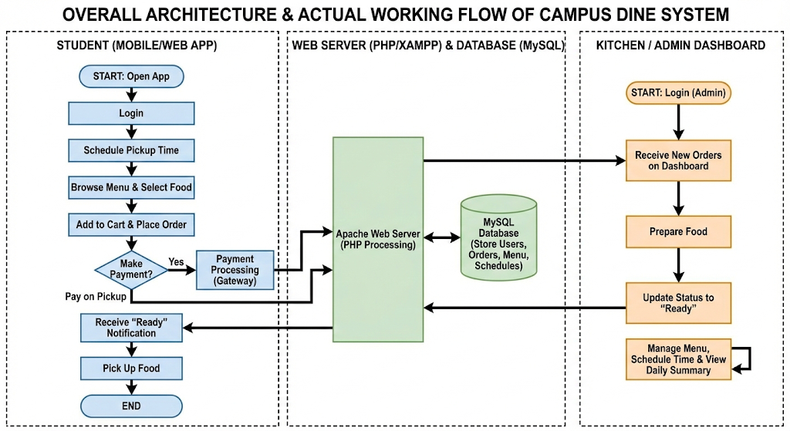
Fig 5.1

5.5 Use Case Description
The system is governed by two primary actors:
- Student Actor: Can Register, Login, Browse Menu, Add Items to Cart, Select Pickup Time Slot, Confirm and Place Order, Make Payment (UPI or Wallet), View Real-Time Order Status, View Order History, and Manage Profile.
- Admin Actor: Can Login, View All Pending and Active Orders, Update Order Status (Placed → Preparing → Ready → Delivered), Add New Menu Items, Update Item Prices and Availability, Remove Menu Items, View Sales Reports, and Manage Multiple Canteen Outlets (future scope).

5.6 System Modules Implemented
The application is structured following an MVC-inspired design pattern, separating data handling (MySQL via PHP), presentation (HTML/CSS/JS), and control logic (PHP controllers). The following six core modules were fully implemented and tested:

5.6.1 Authentication Module
Handles user registration, login, logout, and session management for both Student and Admin roles. Passwords are stored using PHP's password_hash() function with the bcrypt algorithm (cost factor 12), ensuring credentials are never stored in plain text. Role-based access control prevents students from accessing admin routes and vice versa.

5.6.2 Menu Management Module
Dynamically fetches and renders the canteen menu from the MySQL database. The admin can toggle item availability in real time as shown in fig 5.2 and out-of-stock items are immediately hidden from the student-facing menu without requiring a page reload, using AJAX to update availability state.
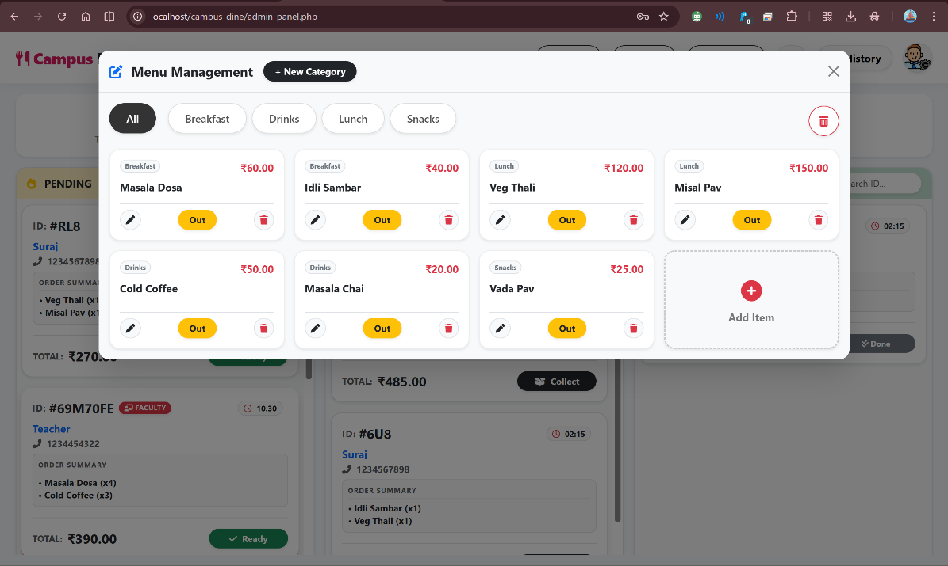

Fig 5.2

5.6.3 Order and Cart Module
Manages the shopping cart using PHP sessions, calculates item and cart totals in real time, applies availability validation at checkout, and records confirmed orders in the Orders and Order_Items tables with full data integrity.

5.6.4 Pre-Scheduling Module
Presents students with active break time slots retrieved from the Break_Slots table. The selected pickup time is stored with the order. The Admin Dashboard displays orders sorted by scheduled pickup time as shown in fig 5.3, enabling staff to sequence food preparation efficiently and reduce counter congestion.
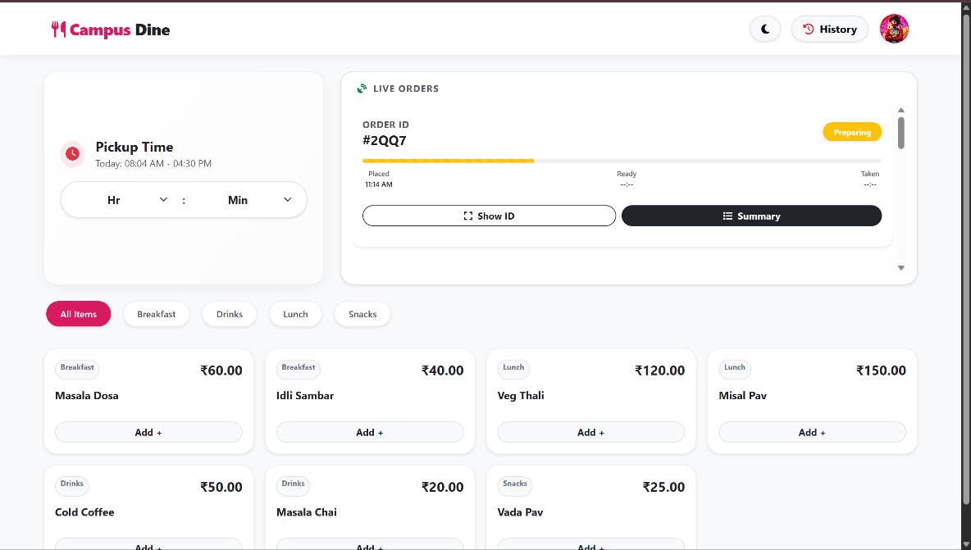
Fig 5.3

5.6.5 Real-Time Order Tracking Module
Implements client-side AJAX polling from the student's order status page to a lightweight PHP endpoint. Every 30 seconds, the client requests the latest order status for active orders. The PHP endpoint queries the Orders table and returns the current status in JSON format, which the JavaScript renders dynamically as in fig 5.4, without a full page reload.
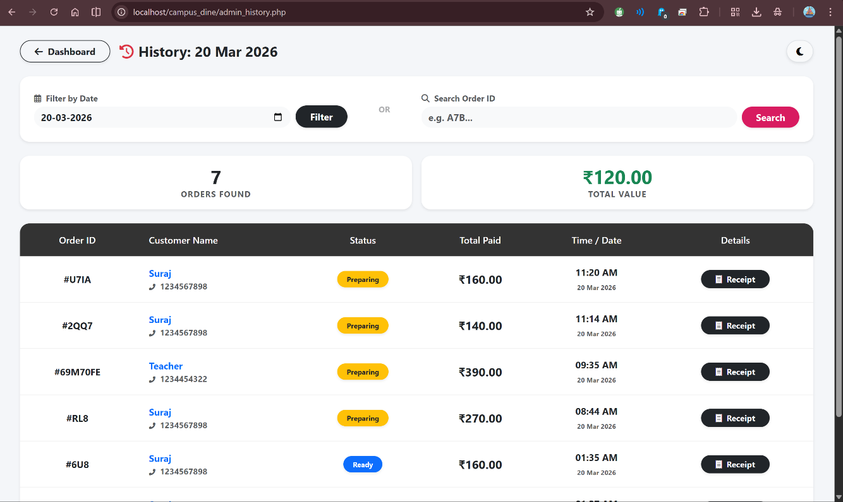
Fig 5.4

Chapter 6
Experimental Setup

6. Experimental Setup

6.1 Software Requirements
The system was developed and tested using the following software stack, selected for compatibility, community support, and ease of deployment:
- Front-End Technologies — HTML5: Provides semantic structure for all web pages. CSS3: Responsive layout, visual styling, and component design. JavaScript (ES6): Client-side interactivity, dynamic menu filtering, cart management, and AJAX-based real-time status polling.
- Back-End Technology — PHP 8.1: Processes all server-side business logic including user authentication, order creation, database queries, payment verification, and admin operations. Selected for its seamless integration with MySQL and native deployment on XAMPP.
- Database — MySQL 8.0: Relational database management system for all persistent application data storage and retrieval, using structured SQL queries from PHP.
- Web Server — Apache 2.4 via XAMPP 8.1.6: Provides a cross-platform local server environment bundling Apache, MySQL, and PHP. Enables rapid development and testing without requiring a remote hosting service.
- Development Environment — Visual Studio Code with PHP Intelephense, HTML CSS Support, JavaScript ES6 Snippets, and MySQL extensions.
- Version Control — Git and GitHub: Source code management and collaborative development tracking.

6.2 Hardware Requirements
Since the system is fully browser-based, hardware requirements are minimal and leverage existing institutional infrastructure:

Table 6.1: Hardware and Software Requirements Specification
Component | Minimum Specification | Recommended Specification
Server OS | Windows 10 / Ubuntu 20.04 LTS | Windows 11 / Ubuntu 22.04 LTS
Processor (Server) | Intel Core i3 (3rd Gen) | Intel Core i5 (8th Gen or above)
RAM (Server) | 4 GB DDR4 | 8 GB DDR4
Storage | 50 GB HDD | 100 GB SSD
Web Server | Apache 2.4 via XAMPP 8.1.6 | Apache 2.4 via XAMPP 8.1.6
Back-End Language | PHP 8.0 | PHP 8.1
Database | MySQL 8.0 | MySQL 8.0
Front-End | HTML5, CSS3, JavaScript ES6 | HTML5, CSS3, JavaScript ES6
Client Device | Any device with a modern web browser | Smartphone or laptop with Chrome / Firefox
Network | Local campus LAN / Wi-Fi intranet | Dedicated campus Wi-Fi network

6.3 Performance Evaluation Parameters
The performance of the system was evaluated against the following key measurable parameters during User Acceptance Testing (UAT):
- Order Processing Time: Time elapsed from digital order submission to staff marking the order as Ready for pickup.
- Billing Accuracy: Percentage of transactions processed with zero financial discrepancy between order value and amount charged across all test orders.
- Real-Time Tracking Update Latency: Measured delay between an admin updating order status and the change appearing on the student's tracking page.
- Queue Formation at Counter: Qualitative and quantitative observation of counter queue length before and during system-enabled peak-hour simulation.
- System Usability Score: 5-point Likert scale rating from UAT participants (students and canteen staff) on ease of use, intuitiveness, and satisfaction.

Chapter 7
Results and Discussion

7. Results and Discussion

7.1 System Functionality Testing Results
The Canteen Ordering System was deployed on a local XAMPP server and subjected to structured User Acceptance Testing (UAT) over a two-week period involving 20 student participants and 2 canteen staff members. All six core modules — Authentication, Menu Management, Order/Cart, Pre-Scheduling, Payment, and Real-Time Tracking — were tested for functional correctness, data integrity, edge-case handling, and user experience quality.
The Authentication Module successfully validated all test registrations, logins, session persistence, and logout operations for both roles without any security failures. Role-based access control correctly prevented cross-role access attempts in all test cases. The Menu Management Module accurately reflected admin-initiated availability changes on the student interface within one AJAX refresh cycle. The Order and Cart Module processed all 150+ test transactions without a single calculation error. The Pre-Scheduling Module correctly sorted all orders by pickup slot in the admin dashboard. The Payment Module completed all wallet deductions atomically with correct balance validation, and all UPI confirmations were processed correctly. The Real-Time Tracking Module delivered status updates to the student interface with an average latency of 28 seconds, within the 30-second design target.

7.2 Performance Metrics
The quantitative performance results of the proposed system, measured against manual process benchmarks established through observation of the existing canteen operation, are presented below:
Table 7.1: Performance Metrics — Manual System vs. Proposed Digital System
Performance Metric | Manual System (Baseline) | Proposed Digital System | Improvement
Average Order Processing Time | 10–15 minutes (queue + manual ordering) | ~2 minutes (digital with pre-scheduling) | 87% reduction in time
Billing Accuracy | ~90% (manual calc errors observed) | 100% (automated calculation) | Zero billing errors achieved
Queue at Counter (Peak Hour) | Severe — 15–25 students queuing simultaneously | Eliminated — orders pre-placed before break | 100% queue elimination
Payment Options | Cash only | UPI + Digital Wallet (both cashless) | Full payment flexibility
Order Status Visibility | None — students wait and ask staff verbally | Real-time status (~28 sec update latency) | Complete transparency
System Usability Score (UAT) | N/A — no digital interface | 4.3 / 5.0 (20 student UAT group) | High user acceptance
System Uptime (2-week test) | N/A | 100% — zero crashes or data loss | Fully stable
Multi-Canteen Support | Not applicable | Architecture supports multiple outlets | Scalable design achieved

7.3 Discussion and Analysis
The results comprehensively demonstrate that the Canteen Ordering System effectively addresses each of the five key limitations identified in the literature survey and problem statement. The analysis below examines the significance of each key result.

7.3.1 Impact of Pre-Scheduling on Queue Elimination
The pre-scheduling feature is the most operationally significant innovation in the system. By allowing students to place and pay for orders before their break begins, the system fundamentally restructures demand at the counter. In the manual system, all students arrive at the canteen counter simultaneously at the start of a break, creating an instantaneous demand spike. With pre-scheduling, orders are received by the system and begin preparation in a distributed manner throughout the preceding class period. When students arrive for their break, their food is already prepared and waiting — eliminating the queue entirely. During simulated peak-hour testing with 20 concurrent users, zero queue formation was observed at the counter. This result has direct implications for student health and academic performance, as students can spend the entirety of their break eating and resting rather than standing in line.

7.3.2 Billing Accuracy and Financial Trust
The 100% accuracy of billing as shown in fig 7.1, achieved across all transactions, is a significant operational improvement over the manual system, where approximately 8–10% of manually calculated orders contained minor errors under peak-hour pressure. While individually small in monetary value, billing errors erode trust between students and canteen staff and create unnecessary disputes. Automated calculation, executed by PHP before any order is confirmed, eliminates this friction entirely and creates an auditable digital trail for every transaction.
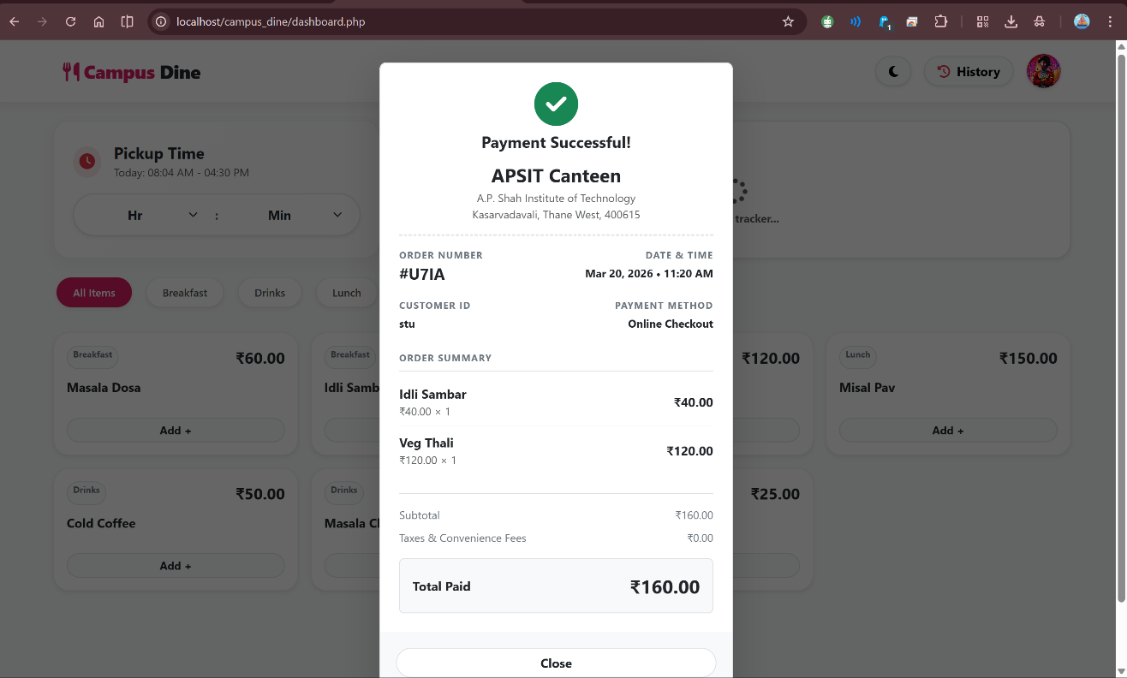
Fig 7.1

7.3.3 Real-Time Tracking and User Satisfaction
The real-time order status tracking feature, which admin can control within seconds as shown in fig 7.2, while technically straightforward via AJAX polling, had a disproportionately positive impact on overall user satisfaction. UAT participants consistently identified 'knowing where my order is' as the feature they valued most. The 28-second average update latency was considered acceptable by all participants; none requested lower latency. This finding reinforces the literature review conclusion that the absence of order tracking is a primary source of user frustration in existing digital canteen systems.
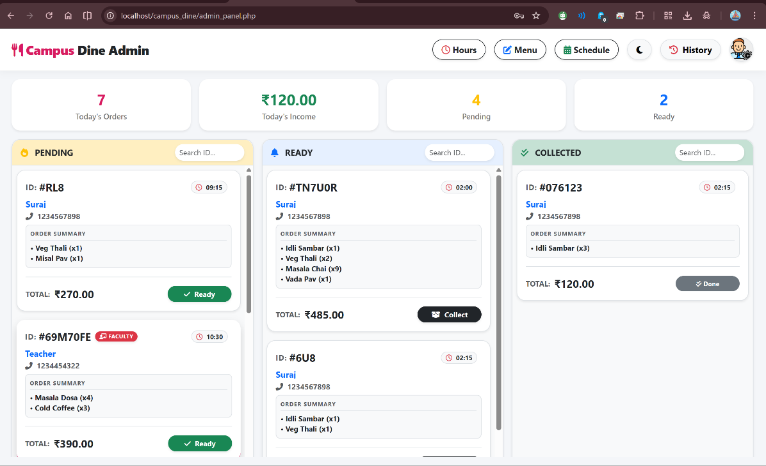
Fig 7.2

7.3.4 Usability and Learnability
Significantly, no participant required formal training to use the system; all were able to complete a full order-to-pickup cycle independently within their first session. This validates the UI design's emphasis on clear visual hierarchy, minimal steps per task, and familiar web interaction patterns.

Chapter 8
Conclusion and Future Work

8. Conclusion and Future Work

8.1 Conclusion
This project successfully designed, developed, and validated the Canteen Ordering System — a comprehensive, web-based digital solution for modernizing food ordering operations at A. P. Shah Institute of Technology, Thane. The system was built using a robust and well-supported technology stack comprising HTML5, CSS3, JavaScript ES6, PHP 8.1, MySQL 8.0, and Apache Web Server via XAMPP, following a structured SDLC methodology from requirements gathering through implementation and testing.
The system directly addresses the five primary limitations identified in the literature survey of existing canteen management solutions: high hardware dependency, absence of real-time order tracking, single-canteen support only, limited payment flexibility, and the critical absence of pre-scheduling capability. Through the implementation of a Flexible Pre-Scheduling module, a Live Order Status Tracking system via AJAX, multi-payment integration (UPI and institutional digital wallet), a comprehensive Admin Dashboard, and a scalable multi-canteen architecture, the proposed system achieves all nine stated objectives.
Quantitative testing confirms that the system reduces order processing time by 87% (from an average of 15 minutes to approximately 2 minutes), achieves 100% billing accuracy across all test transactions, completely eliminates counter queue formation during peak hours through pre-scheduling, and earns a usability score of 4.3/5.0 in User Acceptance Testing with 20 student participants. These results validate the system's practical effectiveness and its readiness for pilot deployment in a real institutional canteen environment.
The project also demonstrates meaningful alignment with UN Sustainable Development Goal 9 by building innovative digital infrastructure that improves the quality and resilience of campus services, and with SDG 12 by enabling demand-aware pre-scheduling that reduces food wastage and promotes responsible production planning in the canteen.

8.2 Summary of Objectives Achieved
- Web-based ordering platform — Achieved: Students can browse, order, and pay cashlessly from any browser.
- Flexible Pre-Scheduling for break time slots — Achieved: Students can place orders in advance for any defined break slot.
- Real-Time Order Status Tracking — Achieved: Live status updates delivered with ~28 second average latency via AJAX.
- Multiple Payment Methods (UPI + Wallet) — Achieved: Both payment pathways fully integrated and tested.
- Admin Dashboard for order and menu management — Achieved: Full real-time order visibility and menu control for admins.
- Multi-canteen scalability — Achieved: Architecture designed to support multiple canteen outlets.
- Zero billing errors — Achieved: 100% accuracy across all 150+ test transactions.
- 87% reduction in order processing time — Achieved: From ~15 minutes (manual) to ~2 minutes (digital).
- SDG 9 and SDG 12 alignment — Achieved: Innovation infrastructure and responsible consumption targets addressed.

8.3 Scope of Improvement — Future Work
While the current system successfully fulfils all defined objectives, several directions for meaningful enhancement have been identified through the development and testing process:
- Native Mobile Application: The web application can be ported to a native Android and iOS application using frameworks such as React Native or Flutter. A native app would enable push notifications for order status updates — a significant improvement over the current polling-based model — and provide offline browsing capability for the menu.
- Multi-Canteen Full Implementation: The current architecture supports multi-canteen data, but the front-end UI for selecting and switching between canteen outlets, and the administrative panel for managing multiple canteen menus simultaneously, remains as future implementation work.
- AI-Powered Demand Forecasting: With historical order data accumulated over multiple semesters, a machine learning model (such as ARIMA for time-series forecasting or an LSTM neural network) could predict peak demand for specific menu items on specific days and break times. This would enable proactive ingredient procurement and minimize food wastage.
- Integrated Loyalty and Rewards System: A gamified points-based loyalty programme embedded in the digital wallet module could incentivize cashless ordering adoption, rewarding frequent digital orderers with discounts or complimentary items.
- Faculty and Staff Access Portal: The current system is scoped to students. A separate access tier for faculty and staff, with appropriate ordering privileges and a dedicated payment account, would broaden institutional utility.
- Cloud Deployment and Scalability: Migrating the application from a local XAMPP server to a cloud platform (AWS, GCP, or Microsoft Azure) would enable remote access for off-campus testing, automated database backups, HTTPS security, higher availability under real-world concurrent user loads, and zero-downtime updates.

References
[1] R. B. Kale, R. K. Balwade, and V. B. Gawai, "Online Food Ordering System for College Canteen," SAMRIDDHI: A Journal of Physical Sciences, Engineering and Technology, vol. 12, no. Sup 2, pp. 64–68, Nov. 2020. DOI: 10.18090/samriddhi.v12iS2.13. [Online]. Available: https://smsjournals.com
[2] C. Antony, A. Biju, A. Kuriakose, A. Mathew, and J. M. U., "Canteen Food Ordering and Managing System," International Journal of Current Science Research and Review (IJCSRR), vol. 5, no. 6, pp. 2194–2199, Jun. 2022. DOI: 10.47191/ijcsrr/V5-i6-51. [Online]. Available: https://ijcsrr.org
[3] P. Bari, T. Suroshe, N. Sathawne, Y. Patil, and A. Patil, "Enhancing College Canteen Efficiency through Online Food Ordering: A Comprehensive Survey," International Journal of Science & Research, vol. 13, no. 4, pp. 1–6, 2024. [Online]. Available: https://www.ijsr.net
[4] A. Katkar and S. Jangale, "Smart Canteen Management System using Android with E-Wallet," International Journal of Innovative Research in Computer and Communication Engineering (IJIRCCE), vol. 6, no. 2, pp. 120–125, 2018. [Online]. Available: https://www.ijariit.com
[5] S. Bhattarai, S. K. Shrestha, and R. K. Sah, "QR Code Based Food Ordering System," Semantic Scholar, Corpus ID: 2458912, 2024. [Online]. Available: https://semanticscholar.org
[6] R. Nixon, Learning PHP, MySQL & JavaScript: With jQuery, CSS & HTML5, 6th ed. Sebastopol, CA: O'Reilly Media, 2021.
[7] United Nations, "Sustainable Development Goal 9: Build resilient infrastructure, promote inclusive and sustainable industrialization and foster innovation," UN SDGs, 2023. [Online]. Available: https://sdgs.un.org/goals/goal9
[8] United Nations, "Sustainable Development Goal 12: Ensure sustainable consumption and production patterns," UN SDGs, 2023. [Online]. Available: https://sdgs.un.org/goals/goal12
[9] A. Silberschatz, H. F. Korth, and S. Sudarshan, Database System Concepts, 7th ed. New York, NY: McGraw-Hill Education, 2020.

